**(INSERT SCHOOL NAME HERE)Semester One Examination, 2023**

**MODERN HISTORY**

**SOURCE BOOKLET**

|  |  |  |
| --- | --- | --- |
| **Source Set** | **Elective** | **Related question** |
| 1 | The Enlightenment 1750–1789 | 1 |
| 2 | The American Revolution 1763–1812 | 1 |
| 3 | The French Revolution 1774–1799 | 1 |
| 4 | The Industrial Revolutions 1750–1890s | 1 |
| 5 | The Age of Imperialism 1848–1914 | 1 |
| 6 | The Meiji Restoration – Japan 1853–1911 | 1 |
| 7 | Capitalism – the American Experience 1907–1941 | 1 |

**Set 1: Elective 1: The Enlightenment 1750–1789**

**Source 1**

*A caricature produced by John Kay (portrait artist of Edinburgh’s local celebrities), 1787. Adam Smith, author of ‘The Wealth of Nations’ is drawn in a bubble of his own thoughts, with Lord Rockville to his left and Commissioner George Brown to his right.*

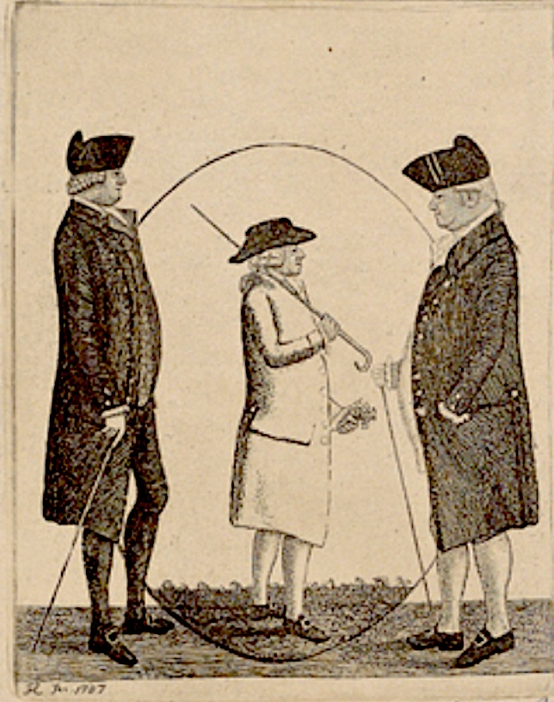

**Source 2**

*Extracts from a review of Adam Smith’s ‘Wealth of Nations’, by D White, printed in the Journal of the History of Ideas, October 1976.*

Why is Adam Smith so famous and particularly, why is the bicentennial of the first edition of *Wealth of Nations* being celebrated with lecture, conferences and the publication of his complete works in elaborate and costly edition? The answer to this rhetorical question is not exactly simple. Some parts of the answer are not difficult. Rightly or wrongly, Adam Smith has been enshrined as the patron saint of the free enterprise system.

… It is also true that Smith’s position seems to be secure, in textbooks at any rate, as the ‘Father of Political Economy’. Certainly, *Wealth of Nations* was an influential book and a genuinely popular one. Reading Smith’s windy periods today, it is rather difficult to appreciate why his contemporaries admired his literary style, as well as his opinions, but they obviously did. *Wealth of Nations* went through five editions in Smith’s lifetime, totalling over 5000 copies. The first edition sold out in six months. T.H. Buckle in his *History of Civilisation England* (1857) mentions that *Wealth of Nations* was cited favourably in Parliament no fewer than thirty-seven times between 1783 and the turn of the century.

rhetorical* - asked to make a statement rather than gain information

**See next page**

**Source 3**

*A cartoon produced in France, 1789. The Abbe (French for cleric) on the left shows a current clergyman, whereas the Abbe on the right is from times prior to the Revolution.*

**Source 4***Extracts from a lecture at the European University, by J. Mokyr, entitled ‘The European Enlightenment, the Industrial Revolution, and Modern Economic growth’. The lecture delivered in March 2007 included previews of Mokyr’s academic thoughts, that would soon be released in his book.*

For many decades, the Enlightenment had little palpable impact on production. What is astonishing, in retrospect, is that the belief in the value of useful knowledge survived so long in the face of a lack of results.

The natural philosophers on whom so many placed their hopes did not know enough and lacked the tools to solve most of the pressing problems quickly… while the results of the Industrial Enlightenment in the eighteenth century were few and far in between, those of the agricultural and medical Enlightenments were even less impressive.

Although the Enlightenment is commonly considered to have ended in 1789, its effects on the economy were, as already indicated, most pronounced in the nineteenth century.

…While economic historians have not found much productivity growth during the classical Industrial Revolution, after 1830 productivity starts to increase and by 1850 its effects on real wages and standard of living become apparent.

**END OF DOCUMENT SET**

**Set 2: Elective 2: The American Revolution 1763–1812**

**Source 1***An illustration by Harry W. McVickar, from a book titled ‘The Boston Tea Party, December 1773’, published, 1882. An American colonist reads the Royal Proclamation relating to the Townshend Acts, 1767. The caption reads ‘T-A-X, ‘T was enough to vex (anger/annoy) the souls of the men of Boston town’.*

**Source 2**

*An extract from the Revenue Act introduced to the British Parliament by Townshend, the Chancellor, 29 June 1767.*

Revenue should be raised, in your Majesty’s dominions in America, for making a more certain and adequate provision for discharging the administration of justice, the support of civil government in such provinces, and towards further financing the defending, protecting, and securing of the American colonies. We, your Majesty’s most dutiful and loyal subjects, the Commons of Great Britain, in Parliament assembled, have therefore resolved to give and grant unto your Majesty the several rates hereinafter mentioned; and do most humbly beseech* your Majesty that it may be enacted. These shall be raised, levied, collected, and paid, unto his Majesty, his heirs and successors, on goods which shall be imported from Great Britain into any colony or plantation in America which now is, or hereafter may be, under the dominion of his Majesty, his heirs or successors. Rates and duties will be charged on glass, lead, painters’ colours, as well as three pence a pound on tea, and on many varieties of paper.

beseech*- ask urgently to do something

**See next page**

**Source 3**

*A print by Philip Dawe, entitled ‘The Bostonians in Distress’ published in a London newspaper, November 1774. The men providing fish represent other American colonies who sent supplies to Boston, during the British blockade.*

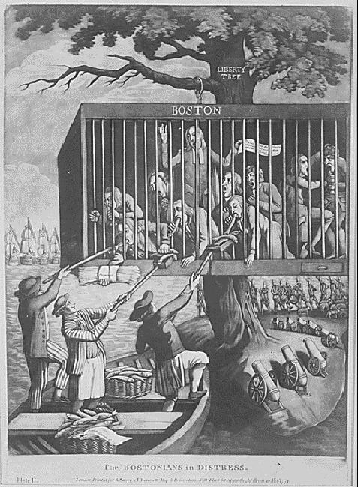

**Source 4***Extracts from an article titled ‘The Economic Effects of the American Revolutionary War’ by Owen Rush, an economic historian, published by The Collector (Canadian academic article website), July 2022.*

During the American Revolutionary War, the economic situation in the colonies was dire. Although the colonies were [surprisingly wealthy](https://www.mountvernon.org/george-washington/colonial-life-today/early-american-economics-facts/#:~:text=Between%201774%20and%201789%2C%20the,resulted%20in%20widespread%20economic%20collapse.) in 1774, the War was costly. Unable to pay currency to attract soldiers, the new United States used land grants to pay soldiers. …Ultimately, this allotment of land for Revolutionary War service totalled over a million acres.

The American Revolutionary War ended America’s valuable trade with Britain. Although this trade had been oppressive due to taxation without representation and [monopolies on imports](https://www.thecollector.com/political-effects-of-american-revolutionary-war/), especially tea, it had been very lucrative for colonial businesses. Credit markets collapsed during the war and afterward, as the new United States was considered a risky investment. Foreign trade was complicated by the fact that America’s two Revolutionary War allies, France and Spain, were more motivated by a chance to defeat Britain than a desire to aid the new nation.

**END OF DOCUMENT SET**

**Set 3: Elective 3: The French Revolution 1774–1799**

**Source 1***A political print by I. Cruikshank titled The Deficit, produced in England, November 1788. King Louis XVI and Necker look at empty chests whilst the noble and clergy are exiting the room with bags of money.*

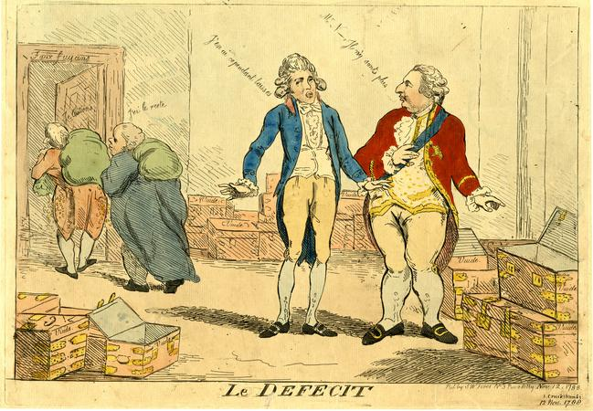

Louis XVI: Where is the tax money?

Necker (Finance Minister): The money was there last time I looked.

**Source 2**

*Extracts from a letter written by Calonne, former Controller-General of French finance to Necker, the current Finance Minister sent in April 1788.*

It is impossible to raise more taxes, ruinous to be always borrowing and not enough to confine ourselves to measures designed to save money. With matters as they are our usual policies will not resolve the financial crisis. The only way of putting the nation’s finances truly in order must consist in reforming the entire state by changing all that is unsound in our constitution.

The problems include a kingdom …. where multiple internal frontiers separate and divide the subjects of the same sovereign; where certain regions are totally freed of taxes, the full weight of which is borne by other regions, where the richest class is the least taxed. Such a state is imperfect, full of corrupt practices and impossible to govern well. In effect the result is that general administration is excessively complicated, public contributions unequally spread, trade hindered by countless restrictions, agriculture crushed by overwhelming burdens, the state’s finances impoverished by excessive costs of recovery and by variations in their yield. These abuses need to be destroyed at their roots in order to eliminate the origin of all obstacles to establishing a more uniform order.

**See next page**

**Source 3**

*A painting by L. Boilly titled ‘Act of Courage of Monsieur Defontenay, Mayor of Rouen, 29th August 1792’. The mayor stands at the entrance of the Hotel De Ville blocking the entry of the bread rioters.*

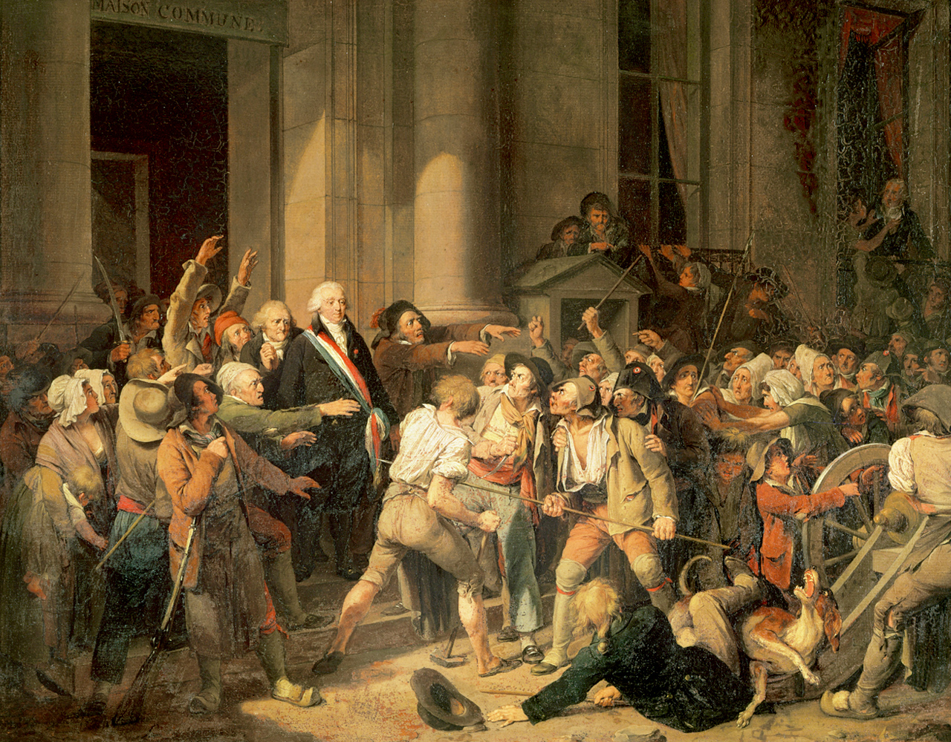

**Source 4***Extracts from Les Revolutions de Paris, a radical newspaper, printed in 1791. The article discusses the seizing of church property.*

Far from bending beneath the paternal hand of the fatherland, far from being at the head of reform that had become indispensable, the upper clergy* allies itself with the nobility… and the priest, who makes a vow of Christian humility, stubbornly persists in maintaining the first rank in the state.

The ministers of a poor God, who possessed nothing on this earth where he might lay his head, haggle** and dispute over every square foot of that third of the land in the kingdom of which they were no more than the beneficiaries…

… My friends, my brothers! Three more months and the country will be saved. Have patience; take courage. The beginnings of liberty are not at all easy. Put on a good face; let harmony reign in our midst. Let us remain united and we shall stay free. Do not let the refusal of a few bishops and several priests (to take the oath) alarm you; that’s their affair. God is on our side, for liberty is his beloved daughter.

clergy* - formal leaders of established religions

haggle* - dispute or bargain persistently

**END OF DOCUMENT SET**

**Set 4: Elective 4: The Industrial Revolutions 1750–1890s**

**Source 1***A satirical cartoon produced during the British railway boom, by Hutchinson. John Bull, shown falling from the drivers cab, was a caricature who represented Britain.*

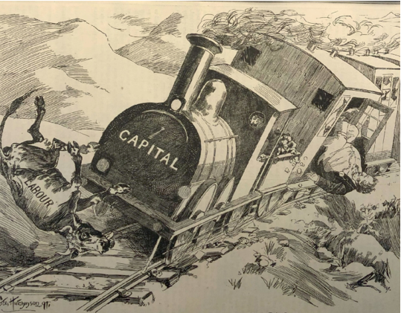

‘Very awkward for the cow,

but also for Mr. Bull and the engine!’

**Source 2**

*An excerpt from the Liverpool and Manchester Railway Company Prospectus, distributed in 1824.*

The immediate and prominent advantages to be anticipated from the proposed railroad are, increased facilities to the general operations of commerce, arising out of that punctuality and dispatch which will attend the transit of merchandise between Liverpool and Manchester, as well as a pecuniary* saving to the trading community. But the inhabitants at large of these populous towns will reap their full share of direct and immediate benefit. Coals will be brought to market in greater plenty, and at a reduced price; and farming produce, of various kinds, will find its way from greater distances, and at more reasonable rates.

To the landlords, also, in the vicinity of the line, the railroad offers important advantages in extensive markets for their mineral and agricultural produce, as well as in a facility of obtaining lime and manure at a cheap rate in return. Moreover, as a cheap and expeditious** means of conveyance for travellers, the railway holds out the fair prospect of a public accommodation, the magnitude and importance of which cannot be immediately determined.

pecuniary* - financial

expeditious** - speedy

**See next page**

**Source 3**

*Illustration of a haulier pulling a wagon of coal, originally published in the Children’s Employment Commission (Mines)1842 Report delivered to the British Parliament.*

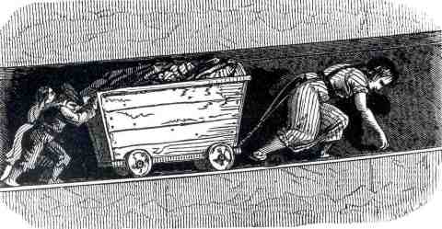

**Source 4***Extracts from William Dodd’s interview with John Reed in 1842. Reed had worked at Richard Arkwright’s Cromford Textile Factory, Derbyshire, UK. Dodd’s worked for Lord Ashley collecting information on child labour.*

John Reed is a sadly deformed young man living in Cromford. He tells his pitiful tale as follows:

"I went to work at the cotton factory of Messrs. Arkwright at the age of nine. I was then a fine strong, healthy lad, and straight in every limb. I had at first instance 2s. per week, for seventy-two hours' work. I continued to work in this factory for ten years, getting gradually advanced in wages, till I had 6s. 3d. per week, which is the highest wages I ever had. I gradually became a cripple, till at the age of nineteen I was unable to stand at the machine, and I was obliged to give it up. The total amount of my earnings was about 130 shillings, and for this sum I have been made a miserable cripple, as you see, and cast off by those who reaped the benefit of my labour, without a single penny.”

I (Dodd) have taken several walks in the neighbourhood of this beautiful and romantic place (Cromford), and seen the splendid castle, and other buildings belonging to the Arkwright’s. …. One might expect that those who have thus risen to such wealth and eminence*, would have some compassion upon their poor cripples. If it is only that they need to have them pointed out, and that their attention has hitherto not been drawn to them, I would hope and trust this case of John Reed will yet come under their notice.

eminence* - fame/superiority

**END OF DOCUMENT SET**

**Set 5: Elective 5: The Age of Imperialism 1848–1914**

**Source 1***A British cartoon produced in 1884 titled ‘The Birdcatcher’. German Chancellor, Bismarck lies next to a cage, labelled ‘German interests’ waiting for the Berlin Conference trap to capture the European powers.*

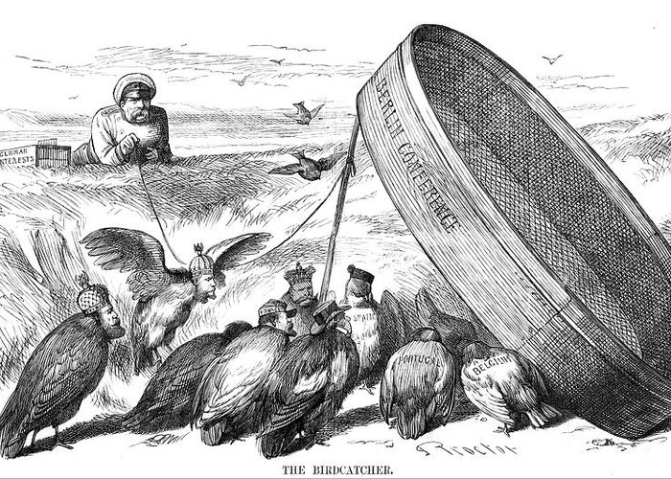

**Source 2**

*Extracts from the article ‘On this day! Carving up Africa …133 years of the Berlin Conference and their licence to colonise’ by Osei Boateng, published in New African magazine, 2018.*

The 26th of February marks the day on which the infamous Berlin Conference that led to the “Scramble for Africa” by European powers … no African was invited to the conference or made privy* to its decisions! Yet we still suffer its consequences!

The history of the Berlin Conference cannot be told without its four main principal characters and features: King Leopold II of Belgium, the British explorer Henry Morton Stanley, the Congo River, and the territory that finally became the two Congo’s.

There were other characters and factors, such as the German Chancellor Otto von Bismarck, who hosted the conference, and the governments of Portugal and France, whose haggling over the Congo Basin in competition with the claims of King Leopold led to the conference. But in essence these characters and factors played bit parts.

…. Leopold got the lion’s share: 905,355 sq. miles, right from the Atlantic Ocean to the very heart of Africa’s interior, encompassing the whole 3,000-mile length of the Congo River and its many tributaries!

privy* - sharing in the knowledge

**See next page**

**Source 3**

*An American cartoon from Puck magazine, published in 1898 entitled ‘Commerce vs. Conquest’’. Uncle Sam and John Bull (character that represents England) offer gifts of ‘trade’ to the Chinese Emperor, whilst Germany, France, and Russia (left to right) stand in the background.*

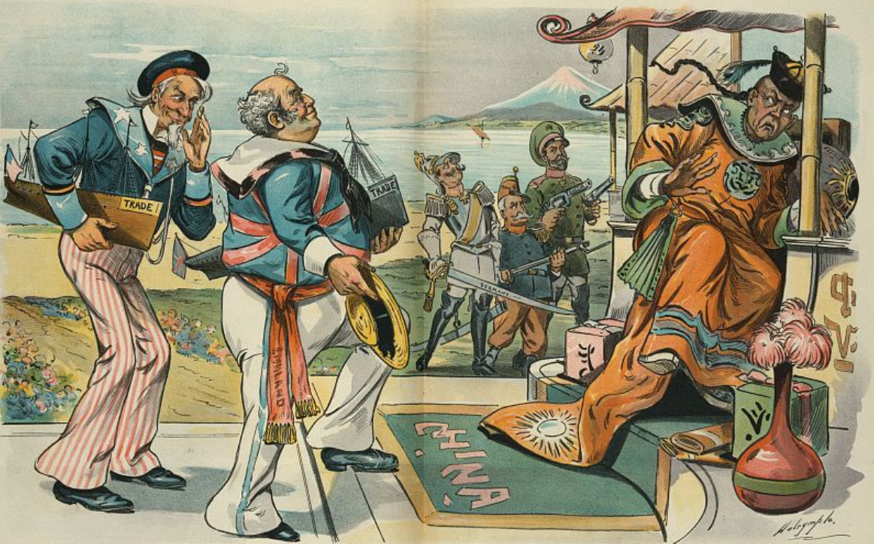

Uncle Sam: Don’t scare him, John, the way those other fellows are doing.

Tell him all we want is to have him open his harbors and markets to everybody!

**Source 4**

*Extracts from the article ‘The economics of missionary expansion’ by Jedwab, Selhausen and Moradi, published in the Journal of Economic Growth in April 2022.*

One of the most powerful cultural transformations in modern history has been the rapid expansion of Christianity to regions outside Europe… The economics behind the expansion of Christianity, and church planting in particular, remains poorly understood…

One narrative describes missionaries as explorers and adventurers crossing political boundaries and whose objective was to save souls no matter the costs. Their knowledge of the area was limited and their locational choices were often erratic, but once settled, missions remained there permanently…. An alternative view is that missionaries were following clear mission strategies designed by their own mission society. Prior to settlement, missionaries thoroughly explored the area to assess the best locations and their locational choices included deep economic considerations. For example, Nunn (2010) lists as important local factors “access to a clean water supply, the ability to import supplies from Europe, and an abundance of fertile soil that could be used to grow crops.”

… However, descriptive evidence suggests that mission societies expanded in more developed areas because they crucially depended on African contributions and Africans saw Christianisation as a way to improve their economic well-being.

**END OF DOCUMENT SET**

**Set 6: Elective 6: The Meiji Restoration – Japan 1853–1911**

**Source 1***A cartoon from a German satirical magazine, published in 1873. Members of the Iwakura Mission are shown inspecting cannons at the Krupp armaments factory, Essen.*

The Japanese will transfer what they learn from

European civilisation into their plans.

**Source 2**

*Extracts from the article ‘The Iwakura Mission: Japan’s 1871 Voyage to Discover the Western World’ by Izumi Saburō (founder of the Iwakura Mission Society), published on nippon.com website, June 2019.*

The mission’s members visited 120 cities and settlements in 12 countries, where they observed and sincerely strove to learn about every aspect of Western civilization from politics and administration to the military, diplomacy, economics, industry, education, religion, transportation, communications, culture, and recreation. They also conferred with monarchs, prime ministers, business leaders, and top academics.

…The voyage was built around research. Every day, members of the delegation debated and studied, while their shared experience and understanding led to policy decisions based on actual conditions following their return.

…In early Meiji, the generation that would build a new Japan were awed by the potential applications of Western civilization, and sought to absorb them. Yet too much emphasis on material progress set Japan on a mistaken path of militarism. After World War II, the country adopted a pacifist Constitution that it has upheld ever since.

**See next page**

**Source 3**

*A print by Utagawa Hiroshige III, produced in 1872, illustrating Japan’s first rail service that ran from Tokyo to Yokohama.*

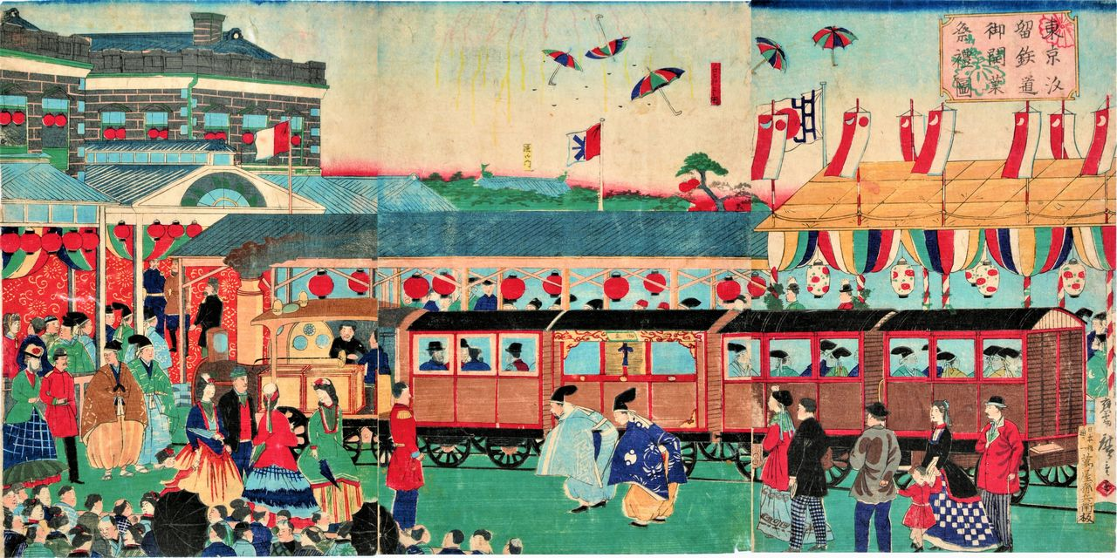

# Source 4*Extracts from ‘Exploring Women Workers in Meiji Japan: The Underclass of Japanese Industrialization with a Chinese comparison’ by Semiha Karaoğlu, published in 2020.*

The Meiji Restoration was a stage for a shift in the history of both Japan and Japanese women. Throughout the Meiji Era, the life of women evolved in diverse aspects. The Empire of Japan, for instance, employed a vast quantity of female workers from small villages or various suburban districts to decrease the gap in the Japanese industrial workforce.

During the initial steps of Japanese industrialization, accordingly, Japanese women worked in factories, facilities, and industrialized localities under poor conditions. The bottom line here, however, is that the factory managers—or employers in a more general term—continually exploited women employees and disregarded any freedom of theirs. During the industrialization of Japan, women made up 80 percent of the workforce in the booming textile industry.

The standards of the factories these women worked in were low. Women employees were overworked, overcrowded, and underpaid. Due to poor treatment and unhygienic work conditions, workers would often get sick, making them take time off and causing them to lose pay. To make things worse, some employers would trap the women inside and forbid them to leave to make more money.

**END OF DOCUMENT SET**

**Set 7: Elective 7: Capitalism – the American Experience 1907–1941**

**Source 1**

*Cartoon by D.R. Fitzpatrick, published in the St. Louis Post newspaper, September 1924, titled ‘The cash register chorus’. A group of businessmen sing about President’s Coolidge’s laissez faire business policies.*

**Source 2**

*Extracts from the book ‘The Perils of Prosperity, 1914-1932’ by W.E. Leuchtenburg, first published in 1958.*

Critics of big business in the 1920s emphasized not only the increase in concentration, but also the fact that the benefits of technological innovation were by no means evenly distributed. Corporate profits and dividends far outpaced the rise in wages, and despite the high productivity of the period, there was a disturbing amount of unemployment. At any given moment in the “golden twenties,” from 7 to 12 percent were jobless.

… At the height of Coolidge prosperity, the secretary of the Gastonia Chamber of Commerce boasted that children of fourteen were permitted to work only 11 hours a day. Perhaps as many as two million boys and girls under fifteen continued to toil in textile mills, cranberry bogs, and beet fields. In 1929, 71 percent of American families had incomes under $2,500, generally thought to be the minimum standard for a decent living. The 36,000 wealthiest families received as much income as the 12,000,000 families—42 percent of all those in America—who received under $1,500 a year, (lived) below the poverty line.…

**See next page**

**Source 3**

*A cartoon by Ed Graham published in a New York magazine, December 1929. Two unemployed men ride in Central Railway company carriage. The caption reads ‘It seems like only yesterday that I had stock in this company!’*

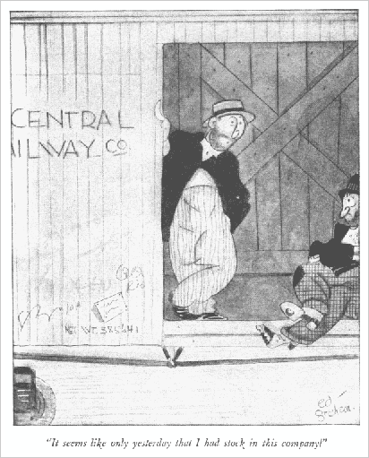

**Source 4**

*Extracts from the article ‘The real lesson of the New Deal: Biden can’t make unforced errors’ by J.S. Smith, published May 2021 on The Washington Post website.*

Observers on the left and right (of politics) have likened Biden’s ambitious agenda to that of President Franklin D. Roosevelt, whose New Deal transformed the nation in the 1930s, building public works projects and providing relief and employment to those hit hard by the Great Depression.

…Roosevelt’s team worked strenuously to strike a balance between public administration and private capitalism, all while eliciting the tangible* support of state and local governments. At the same time, they were not afraid to deploy federal resources and spend public funds on a massive scale. ...While many middle- and upper-class Americans welcomed improved infrastructure and the economic recovery generated by Roosevelt’s administration, a smaller but still substantial number resented the idea of public funds going to the WPA (Works Progress Administration) workforce.

…. Roosevelt commanded a far greater majority than Biden, and even his most popular program (WPA) generated backlash**. Biden can ill afford a less smooth rollout .... that enable his critics to caricature the entire program.

*tangible – real and not imaginary

**backlash – strong negative reaction

**END OF DOCUMENT SET**

**ACKNOWLEDGEMENTS**

**Set 1: Elective 1: The Enlightenment 1750–1789**

**Source 1** *A caricature produced by John Kay (who created portraits of Edinburgh’s local celebrities), 1787. Adam Smith, author of The Wealth of Nations is drawn in a bubble of his own thoughts, with Lord Rockville to his left and Commission George Brown to his right.*

Retrieved from <https://www.herripedia.com/smith-adam-wealth-of-nations/>

**Source 2** *Extracts from a review of Adam Smith’s Wealth of Nations, by D White, printed in the Journal of the History of Ideas, October 1976.*

*Retrieved from* <https://www.jstor.org/stable/2709034>

**Source 3** *A cartoon produced in France, 1789. The Abbe (French for cleric) on the left shows a current clergyman, whereas the Abbe on the right is from times prior to the Revolution.*

Retrieved from https://www.liberation.fr/livres/2019/12/18/eglise-et-etat-un-siecle-de-querelles-en-lumieres_1769979/

**Source 4** *Extracts from a lecture by J. Mokyr, entitled ‘The European Enlightenment, the Industrial Revolution, and Modern Economic growth. Mokyr delivered the lecture at the European University, March 2007.*

*Retrieved from* https://faculty.wcas.northwestern.edu/jmokyr/Florence-Weber.PDF

**Set 2: Elective 2: The American Revolution 1763–1812**

**Source 1** *An illustration by Harry W. McVickar, from a book titled ‘The Boston tea party, December 1773’, published, 1882.*

*Retrieved from* <https://www.alamy.com/tax-on-tea-colonists-learn-of-the-tea-act-of-1773-which-led-to-the-boston-tea-party-rebellion-on-16th-december-1773-image244342427.html?imageid=509CF798-2734-43C3-9C8C-9B768B364522&p=16392&pn=1&searchId=4cd54f6cefe6fed5beffa4f866ff2da0&searchtype=0>

**Source 2** *An extract from the Revenue Act introduced to the British Parliament by Townshend, the Chancellor, 29 June 1767.*

*Retrieved from AQA Exam 2G ‘The Birth of the USA’, 2018*

**Source 3** *A print by Philip Dawe, entitled ‘The Bostonians in Distress’ published in a London newspaper, November 1774. The men providing fish represent other American colonies who sent supplies to Boston, during the British blockade.*

*Retrieved from* <https://www.digitalhistory.uh.edu/disp_textbook.cfm?smtID=8&psid=4201&filepath=http://www.digitalhistory.uh.edu/primarysources_upload/images/bostonians_LG.gif>

**Source 4** *Extracts from George Washington’s resignation address to Congress, 23 December 1783.*

*Retrieved from AQA Exam 2G ‘The Birth of the USA’, 20?*

**Set 3: Elective 3: The French Revolution 1774–1799**

**Source 1** *A political print by I. Cruikshank titled The Deficit, produced in England, November 1788. King Louis XVI and Necker look at empty chests whilst the noble and clergy are exiting the room with money.*

Retreived from <https://www.britishmuseum.org/collection/object/P_1868-0808-5791>

**Source 2** *Extracts from a letter written by Calonne, former Controller-General of French finance to Necker, current Finance Minister, April 1788.*

Retrieved from *WJEC Exam ‘France in Revolution’, 2017*

**Source 3** *A painting by L. Boilly titled ‘Act of Courage of Monsieur Defontenay, Mayor of Rouen, 29th August 1792’. The mayor stands at the entrance of the Hotel De Ville blocking entry to the bread rioters.*

Retrieved from <https://www.bridgemanimages.com/en/noartistknown/title/notechnique/asset/182000>

**Source 4** *Extracts from Les Revolutions de Paris, a radical newspaper, printed in 1791. The article discusses seizing of church property.*

Retrieved from <https://alphahistory.com/frenchrevolution/newspaper-seizing-church-property-1791/>

**Set 4: Elective 4: The Industrial Revolutions 1750–1890s**

**Source 1** *A satirical cartoon produced during the British railway boom, by Hutchinson. John Bull was a caricature who represented Britain.*

Retrieved from <https://link.springer.com/chapter/10.1007/978-3-030-86604-4_6>

**Source 2** *An excerpt from the Liverpool and Manchester Railway Company Prospectus, distributed in 1824.*

Retrieved from <https://spartacus-educational.com/RAliverpool.htm>

**Source 3** *Illustration of a haulier pulling a wagon of coal, originally published in the Children’s Employment Commission (Mines)1842 Report delivered to the British Parliament.*

Retrived from <https://museum.wales/childrenoftherevolution/work/resources/images/>

**Source 4** *Extracts from William Dodd’s interview with John Reed in 1842. Reed had worked at Richard Arkwright’s Cromford Textile Factory, Derbyshire, UK. Dodd’s worked for Lord Ashley collecting information on child labour.*

Retrieved from <https://spartacus-educational.com/IRdodd.htm>

**Set 5: Elective 5: The Age of Imperialism 1848–1914**

**Source 1** *A British cartoon produced in 1884 titled ‘The Birdcatcher’. German Chancellor, Bismarck lies next to a cage, labelled ‘German interests’ waiting for the Berlin Conference to trap the European powers.*

Retreived from <https://fineartamerica.com/featured/berlin-conference-bismarck-hopes-that-mary-evans-picture-library.html?product=greeting-card>

**Source 2** *Extracts from the article ‘On this day! Carving up Africa …133 years of the Berlin Conference and their licence to colonise’ by Osei Boateng, published in New African magazine, 2018.*

Retreived from <https://newafricanmagazine.com/16411/>

**Source 3** *An American cartoon from Puck magazine, published in 1898 entitled ‘Commerce vs. Conquest’’. Uncle Sam and John Bull (character that represents England) offer gifts of ‘trade’ to the Chinse Emperor, whilst Germany, France and Russia stand in the background.*

*Retrieved from* <https://www.loc.gov/resource/ppmsca.28776/>

**Source 4** *Extracts from the article ‘The economics of missionary expansion’ by Jedwab, Selhausen and Moradi, published in the Journal of Economic Growth in April 2022.*

Retrieved from <https://link.springer.com/content/pdf/10.1007/s10887-022-09202-8.pdf?pdf=button>

**Set 6: Elective 6: The Meiji Restoration – Japan 1853–1911**

**Source 1** *A cartoon from a German satirical magazine, published in 1873. Members of the Iwakura Mission are shown inspecting cannons at the Krupp factory, Essen.*

Retrieved from <https://www.alamy.com/visit-of-the-iwakura-mission-at-the-krupp-factory-in-essen-caricature-from-berliner-wespen-no-12-21-march-1873-1873-private-collection-image444363886.html>

**Source 2** *Extracts from the article ‘The Iwakura Mission: Japan’s 1971 Voyage to Discover the Western World’ by Izumi Saburō, published on nippon.com, June 2019.*

Retrieved from <https://www.nippon.com/en/japan-topics/g00680/the-iwakura-mission-japan%E2%80%99s-1871-voyage-to-discover-the-western-world.html>

**Source 3** *A print by Utagawa Hiroshige III, produced in 1872, illustrating Japan’s first rail service that ran from Tokyo to Yokohama****.***

Retrieved from <file:///C:/Users/sarah/Downloads/exploring-women-workers-in-meiji-japan-the-underclass-of-japanese-industrialization-with-a-chinese-comparison.pdf.pdf>

# Source 4 *Extracts from ‘Exploring Women Workers in Meiji Japan: The Underclass of Japanese Industrialization with a Chinese comparison’ by Semiha Karaoğlu, pp. 15-16 published in 2020.*

# Retrieved from <file:///C:/Users/sarah/Downloads/exploring-women-workers-in-meiji-japan-the-underclass-of-japanese-industrialization-with-a-chinese-comparison.pdf.pdf>

**Set 7: Elective 7: Capitalism – the American Experience 1907–1941**

**Source 1** *Cartoon by D.R. Fitzpatrick, published in the St. Louis Post newspaper, September 1924, titled ‘The cash register chorus’. A group of businessmen sing about President’s Coolidge laissez faire policies.*

Retrieved from [The cash register chorus. - Editorial Cartoons - Digital Collections (shsmo.org)](https://digital.shsmo.org/digital/collection/ec/id/11241/rec/17)

**Source 2** *Extracts from the book ‘The Perils of Prosperity, 1914-1932’ by W.E. Leuchtenburg, first published in 1958.*

Retrieved from <https://www.nysedregents.org/ushistorygov/616/ushg62016-examw.pdf>

**Source 3** *A cartoon by Ed Graham published in a New York magazine, December 1929. The caption reads ‘It seems like only yesterday that I had stock in this company!’*

Retrived from <http://www.archelaus-cards.com/archives/20090112.php>

**Source 4** *Extracts from the article ‘The real lesson of the New Deal: Biden can’t make unforced errors’ by J.S. Smith, published May 2021 on The Washington Post website.*

Retrieved from <https://www.washingtonpost.com/outlook/2021/05/04/real-lesson-new-deal-biden-cant-make-unforced-errors/>

**END OF SOURCE BOOKLET**